CUSTOMER CHURN PREDICTION & LTV ENGINE

Week 1 Progress Report

Prepared By:
Archita Jar

Internship Domain:
Data Analytics

Date:
15 June 2026

Project Objective
The objective of this project is to analyze customer churn patterns using the Telco Customer Churn dataset and identify factors influencing customer retention. The findings will be used to build predictive machine learning models in subsequent phases.
- Database Setup
Tools Used:
- PostgreSQL 18
- pgAdmin 4
Tasks Completed:
- Installed PostgreSQL and configured pgAdmin.
- Created database: customer_churn
- Created table: churn_data
- Imported Telco Customer Churn dataset.
- Verified successful data loading using SQL queries.
SQL Validation Results:
- Total Customers: 7043
- Retained Customers: 5174
- Churned Customers: 1869
- Exploratory Data Analysis (EDA)
Tools Used:
- Python
- Pandas
- Matplotlib
- Seaborn
- VS Code
Tasks Completed:
- Loaded dataset using Pandas.
- Verified dataset dimensions.
- Inspected dataset columns.
- Checked for missing values.
- Generated visualizations to identify churn trends.
Dataset Information:
Metric | Value
Total Records | 7043
Total Features | 21
Missing Values | 0
Churned Customers | 1869
Retained Customers | 5174
- Total Rows: 7043
- Total Columns: 21
- Missing Values: 0
- Visualizations and Findings
A. Customer Churn Distribution
Observation:
The dataset contains 1869 churned customers and 5174 retained customers. Approximately 26.5% of customers have churned.
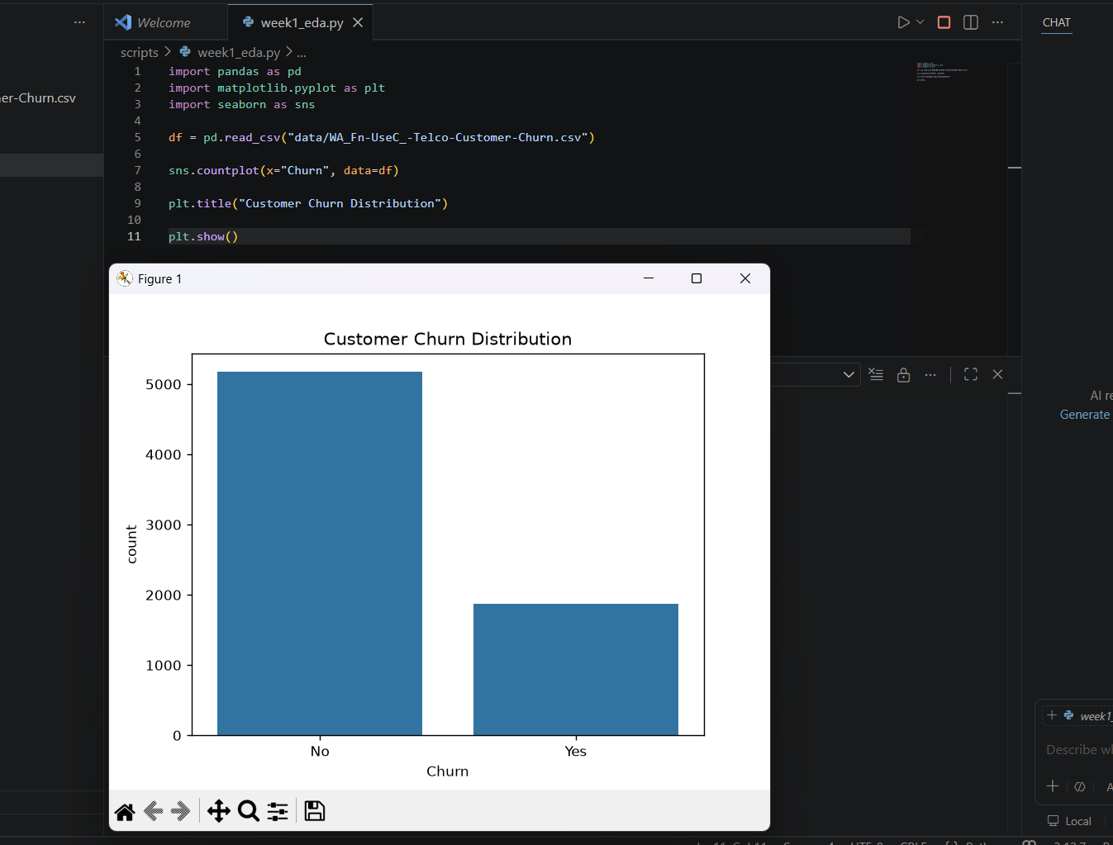
Figure 1: Customer churn distribution
B. Contract Type vs Churn
Observation:
Month-to-month customers exhibit the highest churn rate. Customers with one-year and two-year contracts are significantly more likely to remain with the company.
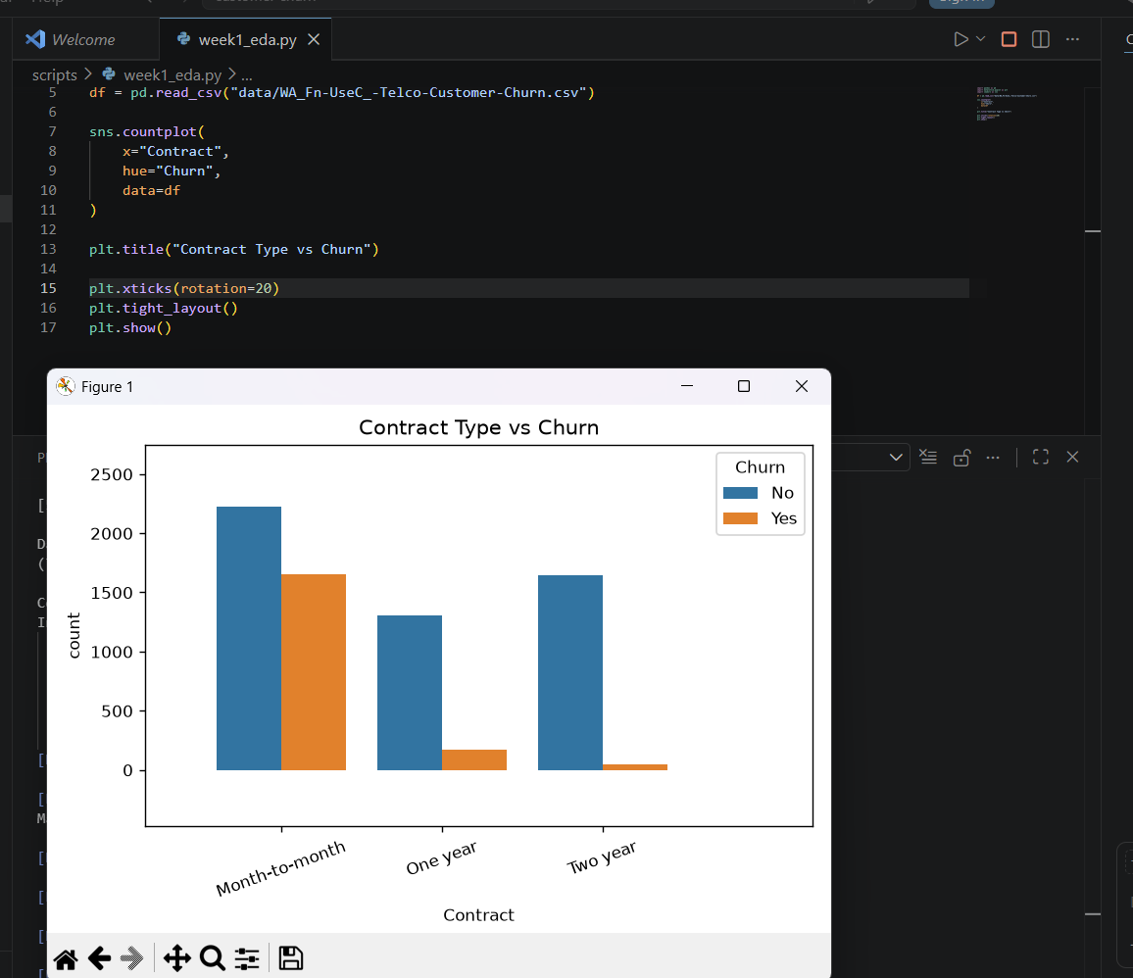
Figure 2: Contract Type vs Churn
C. Tenure vs Churn
Observation:
Customers with shorter tenure are more likely to churn. Long-term customers demonstrate stronger retention behavior.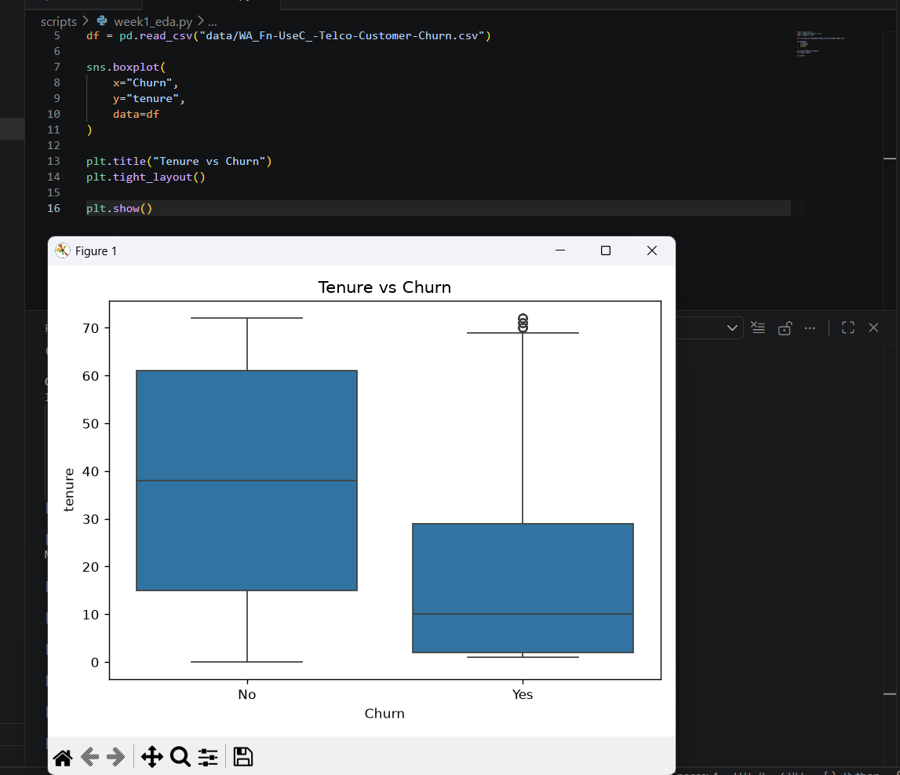
Figure 3: Tenure vs Churn
D. Monthly Charges vs Churn
Observation:
Customers with higher monthly charges show a greater tendency to churn compared to customers paying lower monthly charges.
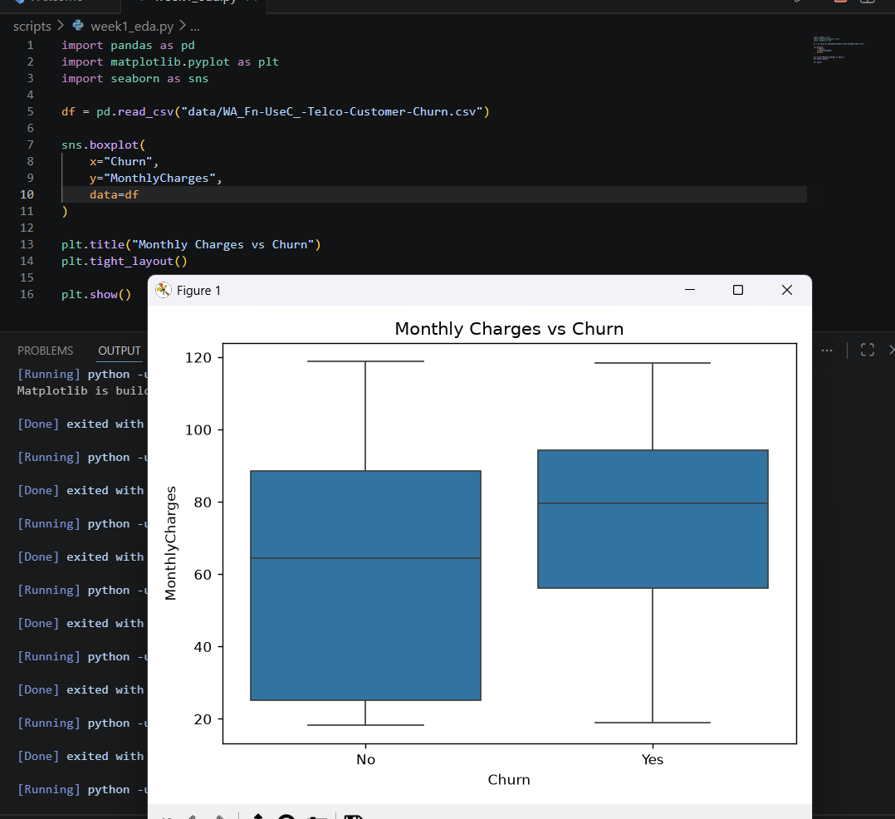
Figure 4: Monthly Charges vs Churn
- Key Insights
- Contract type is a strong indicator of customer churn.
- Customers in the early stages of their subscription are more likely to leave.
- Higher monthly charges are associated with increased churn probability.
- The dataset is clean and suitable for predictive modeling.
- Next Steps (Week 2)
- Feature Engineering
- Data Encoding
- Model Development
- Logistic Regression
- Random Forest
- Model Evaluation
- Feature Importance Analysis
Conclusion
Week 1 objectives were successfully completed. The Telco Customer Churn dataset was imported into PostgreSQL, validated using SQL queries, and analyzed using Python. Exploratory Data Analysis identified several important churn indicators, including contract type, customer tenure, and monthly charges. The dataset was found to be complete with no missing values. The project is now prepared for feature engineering and predictive model development in Week 2.
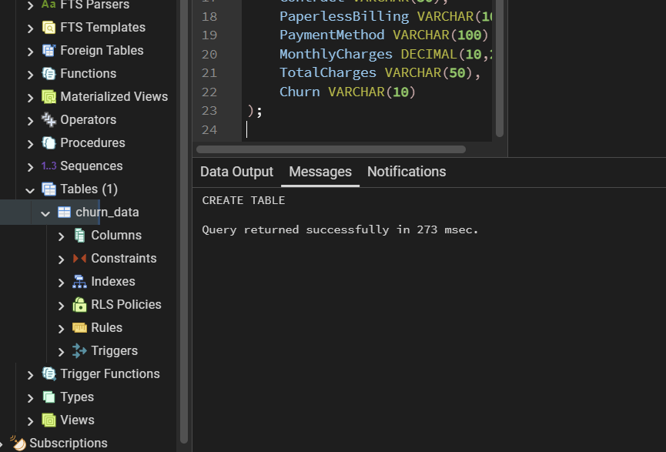
Figure 5: PostgreSQL Database Structure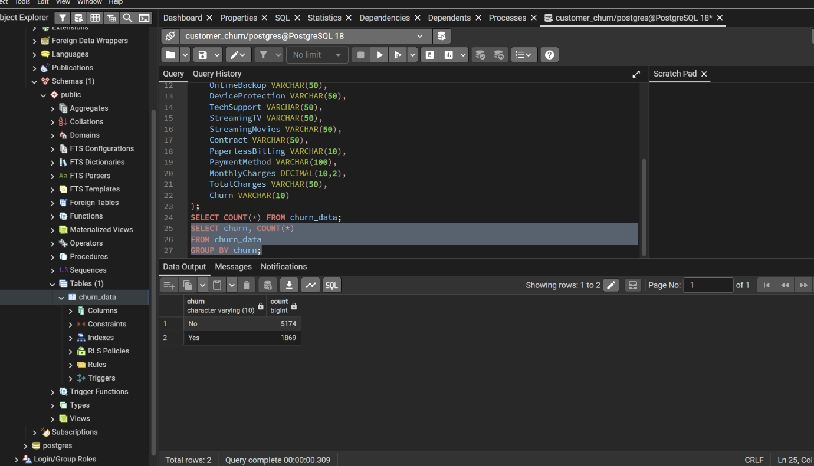
Figure 6: SQL Query Result Showing Customer Churn Counts
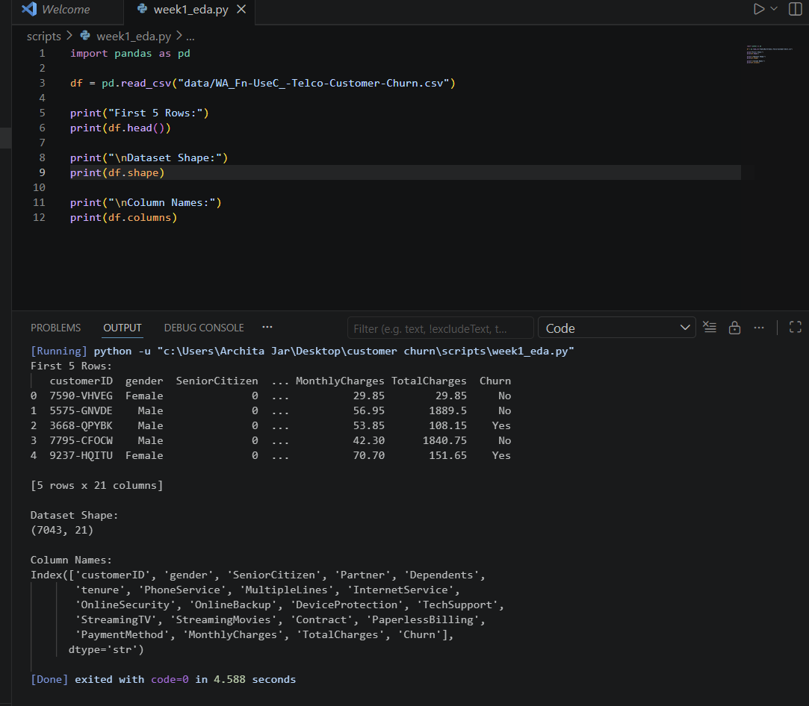
Figure 7: Dataset Loaded Successfully in Python
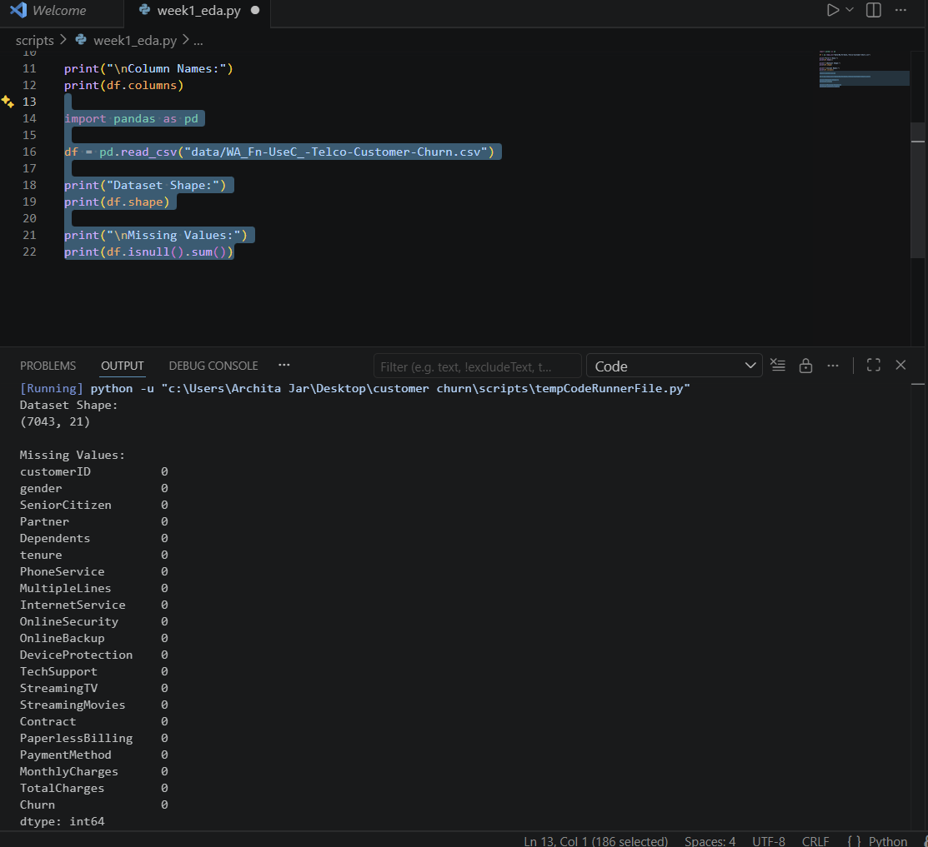
Figure 8: Missing Value Analysis

